To: Professor Pershing

From: Josh Whitehead

Date: 22 Nov 2021

Subject: Ch En 3453 Heat Exchanger Design

**Problem**

Our company is in need of a shell and tube heat exchanger that can use steam at 338°F to heat 5,000 lb/hr of milk from 90°C to 135°C with a maximum pressure drop of 20psi. The milk must not stay above 100°C for longer than 10 seconds.

**Fixed Conditions**

The inlet pressure of the milk is 85 psia and that of steam is 95 psia. The steam condenses at 320°F. Milk and steam have fouling factors of 0.0025 and 0.001 respectively. Tubes must be ½” OD, 12 BWG, 316 stainless steel. The vendor provided specifications regarding the maximum number of tubes in a given shell and these tubes are set on a 1.0” triangular pitch at 30°.

**Considerations**

While considering the best design for this heat exchanger, I decided that the milk should be the fluid in the tube because it has a higher fouling factor so whichever surface it comes into contact with will need to be cleaned more frequently than the surfaces touched by the steam. I decided that 1 tube pass is better than 2 because with 2 passes, the tube length would have to be such that the available area is larger than it would be with 1 pass, making it more expensive than if it had only 1 pass. The driving factors for determining the best design were total cost and efficiency, which is related to pressure drop. The proposed design is the cheapest overall, and has a milk side pressure drop closest to the maximum which makes it the most efficient.

**Alternative Designs**

I considered a design with a 7.25 in shell ID, 5 in central baffle spacing, 20 tubes of 20 ft and 2 passes. While this design fulfills the necessary requirements and has a similar tube side pressure drop, the final cost is estimated to be almost $26,000 more than the proposed design above. Another design I considered has 5.25 in shell ID, 5 in central baffle spacing, 9 tubes of 40 ft and 1 tube pass. This design fulfills all necessary requirements but is almost $7,000 more expensive. It also has a milk side pressure drop of about 8.15 psi which is almost half that of the proposed design so this design would be more expensive and less efficient.

**Solution**

I propose the purchase of a heat exchanger with a 7.25 in shell ID, 5 in central baffle spacing, 7 tubes of 50 ft and 1 tube pass. In this exchanger the milk would flow through the tubes and the steam through the shell. The milk pressure drop would be about 15.8 psi and the steam pressure drop would be about 0.063 psi. The milk would stay above 100°C for about 5 seconds. This exchanger requires about 42.52 ft2 of area with 45.7 ft2 available and has an overdesign factor of about 7.48%. This design also includes the specified fixed conditions and fulfills the requirements previously mentioned. I estimate the purchasing and installation price to be $19,119 and $61,181 respectively with a total cost just over $80,000. A more complete summary of this design is attached at the end of this memo.

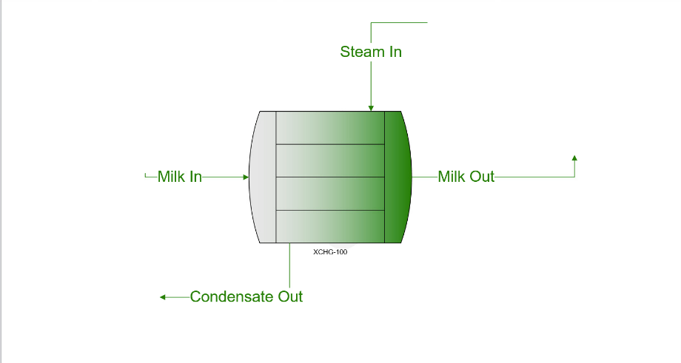

Stream info

Heat exchanger base design

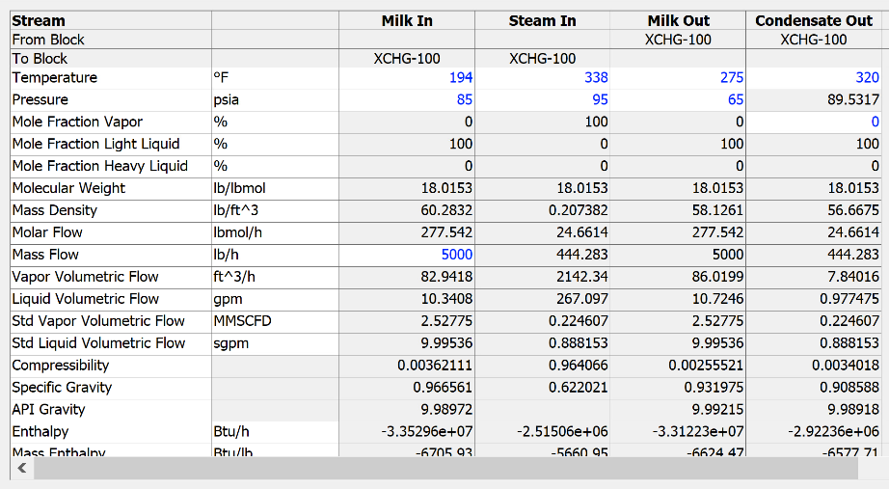

Shell info

Tube info

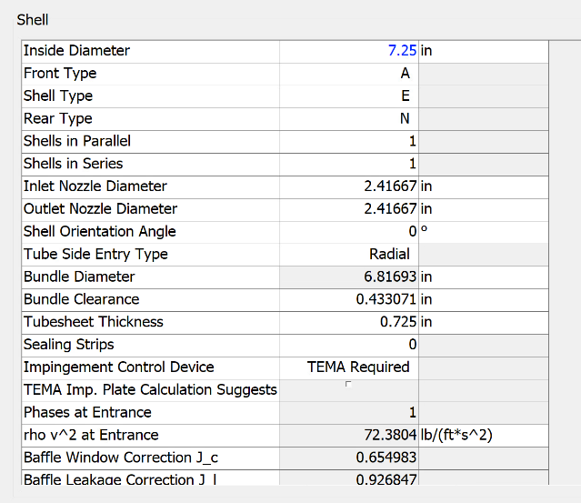

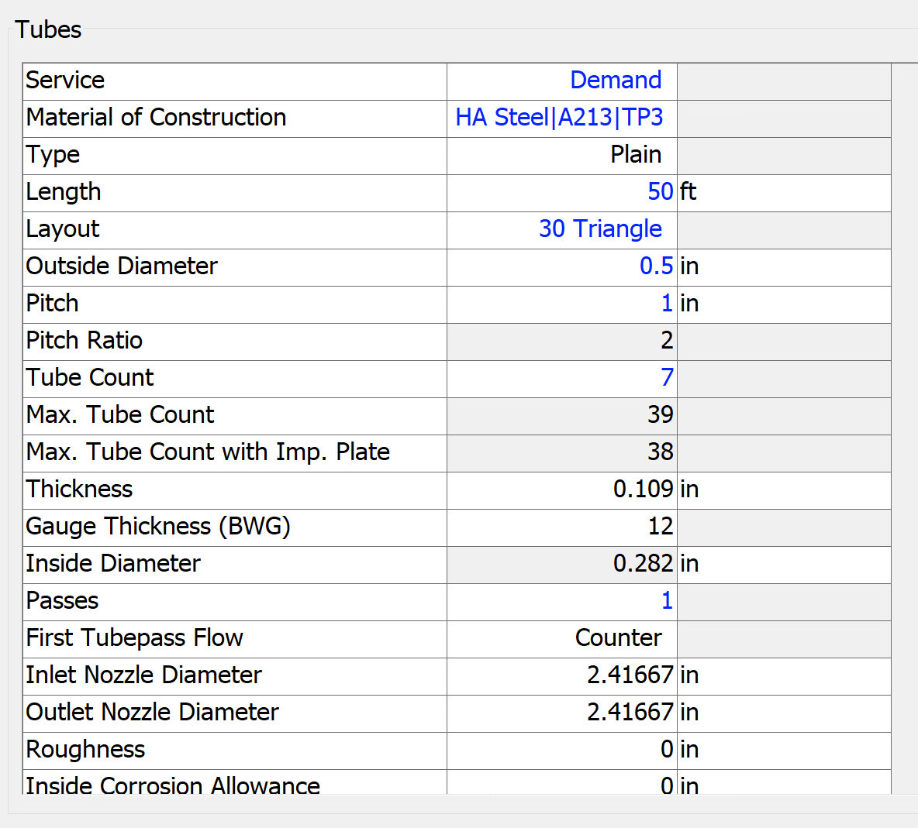

Tube side info (milk)

Shell side info (steam)

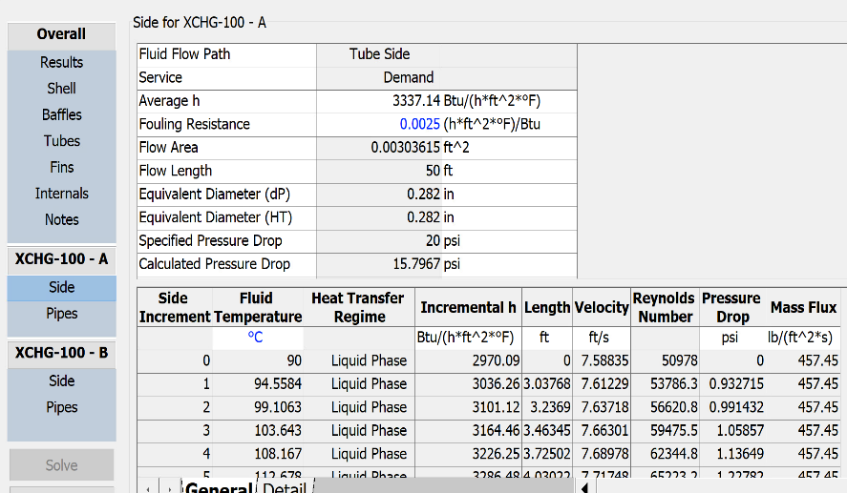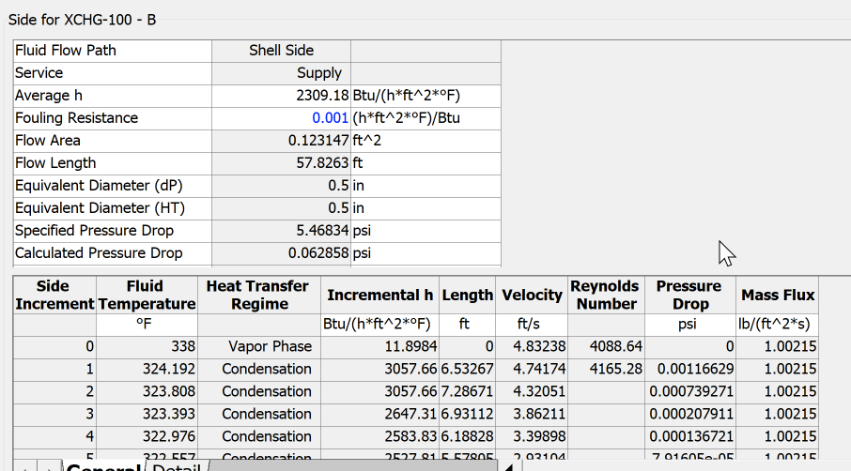

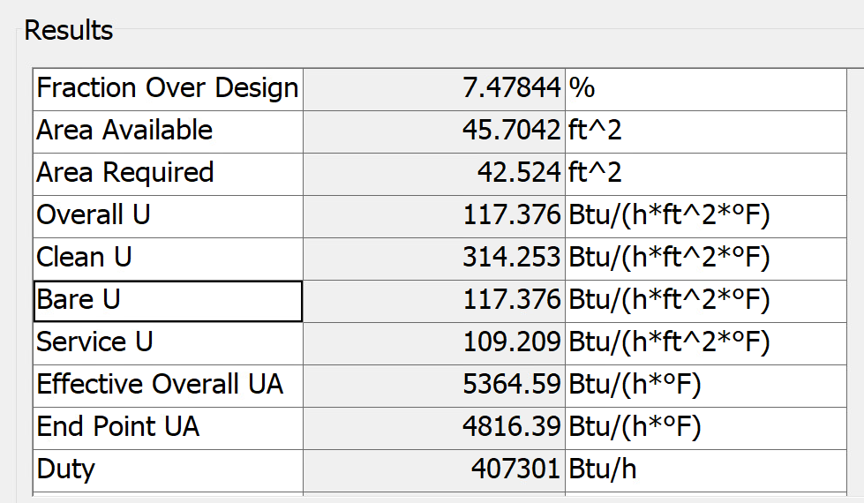

Final results